Give this manual a clear title
Mention the subject
Document Details
Released by: | Company
Document: | Document name
Version: | Version
Author: | Department/name
Datum: | 26 March 2026



Preface
Introduce the product or system in an introduction. Define for whom the document is intended.

For more information, please contact:

Insert your company name, address, and contact details here.

Table of contents
Preface 2
Table of contents 3
1 Introduction 4
1.1 Intended and Unintended Use 4
1.2 Symbols Used in this Manual 4
1.3 Glossary of Terms 4
2 Product or System Description 5
2.1 Product/System Description 5
2.2 Relevant Components 5
2.3 Specifications 6
3 Safety 7
3.1 Safety Instructions 7
4 Installation Instructions 8
4.1 Sub step 1 8
4.2 Sub step 2 8
5 Troubleshooting 9
6 Disposal 9

Introduction

Intended and Unintended Use
Introduce the product or system. Define the intended audience for this document. Specify the intended and unintended use of the product or system.

Symbols Used in this Manual
If symbols are used in the document, explain their meanings in this section:
Symbol image | Explanation of symbol meaning
Symbol image | Explanation of symbol meaning
Symbol image | Explanation of symbol meaning

Glossary of Terms
If specific terms are used in the document, explain their meanings in this section:
Term | Explanation of term
Term | Explanation of term
Term | Explanation of term
Term | Explanation of term
Term | Explanation of term

Product or System Description

Product/System Description
Describe the product.

Relevant Components
Include one or more images of the product. Number the relevant components and specify what these components are.

Insert an image of the product here, with the relevant components indicated by numbers.

Insert an image of the product here, with the relevant components indicated by numbers.

Specifications
Provide relevant technical information (such as dimensions, weight, energy consumption, etc.), specifications, and possible configurations.
Product
Dimension
Weight
Other relevant specifications

Safety

Safety Instructions
Provide clear and detailed safety instructions. Clearly state any potential hazards and the necessary precautions. Emphasise the importance of reading the safety instructions carefully before using the product.
Include the safety instructions with the relevant installation or operating instructions.

Installation Instructions
Divide the Installation Instructions chapter into logical sub-sections. This allows users to easily search for a specific topic.
- Provide step-by-step instructions for installing or setting up the product/system.
- Clearly state which tools or equipment are required to complete the task.
- Add safety instructions where relevant.
- Use images to convey (complex) information where necessary.

Choose a consistent way to style images. For example, place all images in a frame.
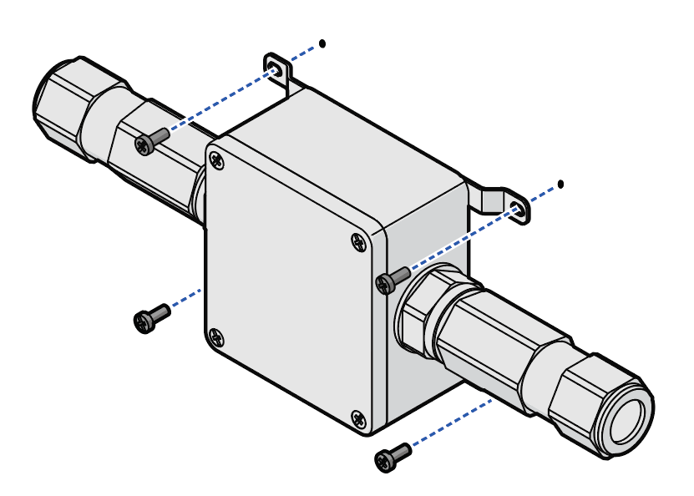

You can find more tips on writing effective work instructions (including a free handy checklist) on our website: www.manualise.com/en/sop/

Sub step 1

Sub step 2

Troubleshooting
Describe common problems and possible solutions. Provide users with steps to identify and resolve issues.

Disposal
State how the product or system can be disposed of in a responsible manner.

